Computational physics exercise 3

# free-fall with a fixed drag coefficient

On the 14th October 2012, Felix Baumgartner broke the record for the highest skydive, jumping from a height of 39045 m. I have written a program which models his jump, first assuming a constant air density and then in section 2 with a varying air density.

For an object falling in air there will be an accelerating force due to gravity of *m****g*** and a decelerating force due to drag. We will model the drag force as being given by **F**= -k**v**2, where k is a coefficient given by:

$$k= \frac{C_{d} ρ A}{2}$$

Cd is the drag coefficient, ρ is the density of the air, and A is the cross sectional area of the object. As mentioned above, for the moment we will assume ρ is constant. Since the acceleration is varying we create two differential equations:

|  |  |  |  |
| --- | --- | --- | --- |
| $$m\frac{dv}{dt}=mg-kv^{2}$$ |  | $$\frac{dy}{dt}=v$$ |  |

We can solve these equations using Euler’s method. i.e.

|  |  |  |  |  |  |
| --- | --- | --- | --- | --- | --- |
| $$v_{n+1}= v_{n} ∆t\left(g+\frac{k}{m}{v_{n}}^{2}\right)$$ |  | $$y_{n+1}=y_{n}+∆t v_{n}$$ |  | $$t_{n+1}=t_{n}+∆t$$ |  |

Alternatively we can solve the equations analytically:

|  |  |  |  |
| --- | --- | --- | --- |
| $$y= y_{0}-\frac{m}{2k} ln\left(\sqrt{\frac{kg}{m}}\right)$$ |  | $$v=-\sqrt{\frac{mg}{k}}tanh\left(\sqrt{\frac{kg}{m}}t\right)$$ |  |

I have written a program which calculates y and v for a given time increment and starting conditions, and outputs this information to a text file in order to allow it to be plotted. The program also calculates the answer analytically for every dt. Hence two sets of data for velocity and height are outputted to a file and their graphs can then be compared.

I estimated the cross sectional area of a skydiver to be 0.6m2, and used a starting height of 1000m. I took the density of air to be 1.2kgm-2. For a skydiver Cd is roughly 1~1.3, I used 1.2. Figure 1 shows the resultant graph:

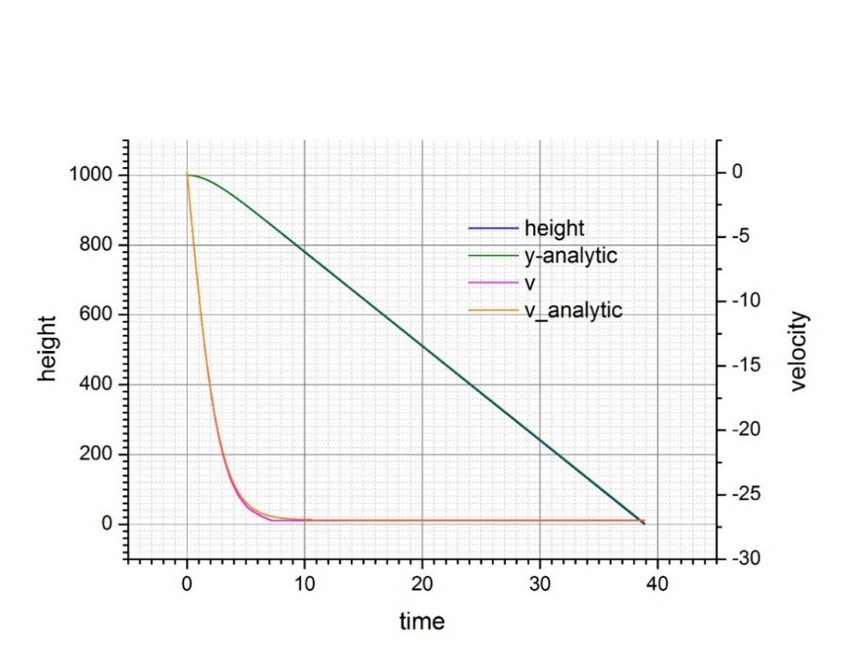

Figure 1: The graph of velocity and height for a skydiver assuming fixed air density

We can see that, as we expect, the skydiver quickly reaches terminal velocity and then continues to fall until he hits the ground at around t=39s. There appears to be little discrepancy between Euler’s method and the answer that has been calculated analytically.

Increasing k increases both the time taken to reach terminal velocity and the time taken to hit the ground. Reducing the mass means it takes less time to reach terminal velocity, but the terminal velocity is slower (and hence it takes longer to hit the ground). This is due to the change in the surface area to mass ratio.

# free-fall with a varying drag coefficient

However, at the height that Felix Baumgartner jumped from, the varying density of air becomes significant. I will model the density of air as:

$$ρ=ρ_{0}\exp\left(\frac{height}{scale height}\right)$$

Where the scale height on earth is about 7.64km, and ρ0 ~ 1.2kgm-2. Again I calculated the answer both analytically and using Euler’s method. I used the same constants as in the last question, except for the start height which I set to 39045m. The graph is shown in figure 2:

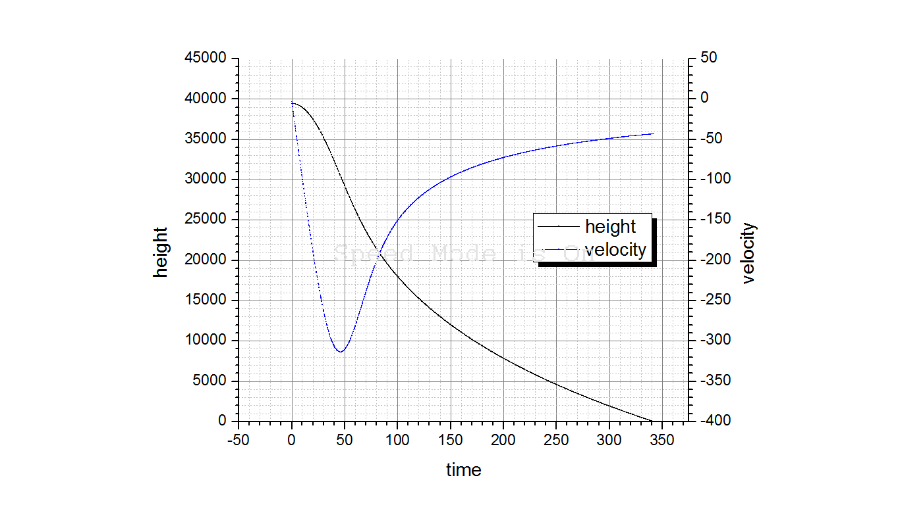

Figure 2: calculated velocity and height for Felix Baumgartner’s fall.

The speed of sound in air is about 340m/s. According to my program the maximum speed Felix Baumgartner achieved was less than 320m/s. However, changing some of the numbers means that Felix may have in fact broken the sound barrier:

Like in the first problem, reducing A or C_d causes a faster velocity to be reached. Again like in the first problem, reducing the mass causes (a lower) terminal velocity to be reached faster. If we set C_d to its lowest value (1.0) then if mass = 91 kg a maximum speed of 340.03m/s is reached. In addition as Felix Baumgartner fell, he tumbled and hence his cross sectional area was often less than the 0.6m I used. This means if Felix Baumgartner was weighed down by enough equipment, it seems likely that he broke the sound barrier.

# approximation of an electric field using relaxation method

Consider a box containing two charged objects. The box itself is grounded. We would like to calculate the electric field created. We can draw the situation:

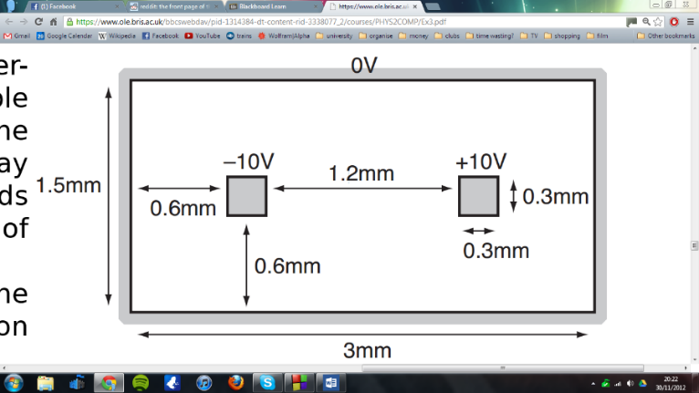

Figure 3. The situation which we are analyzing

We can approximate the field by calculating it at a large number of discrete points. If we choose the bottom left of the rectangle to be the origin then we could for example sample the field every 0.1 mm. Because the potential obeys Laplace’s equation, the potential at any point is given by the average of the neighboring points. In other words, for our 2D situation:

$$V_{new}\left[x,y\right]=0.25*(V_{old}\left[x+∆x , y\right]+V_{old}\left[x-∆x,y\right]+V_{old}\left[x,y+∆y\right]+V_{old}[x,y-∆y]$$

We repeat the above calculation for every point until we have an approximation of the field. My program stores the field at each point in an array and performs this calculation until each value changes by no more than 0.001V. The array is then outputted to a text file, a 3D plot of which is shown in figure 4.

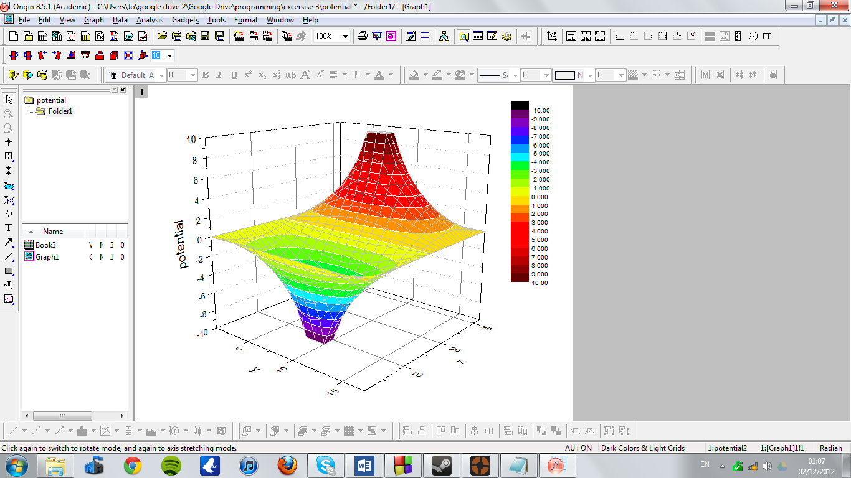

Figure 4. the potential produced by program 3.

My program then calculates the components of the electric field and stores these values in two new arrays. Finally this data is outputted to a text file in a format such that a vector plot of it can be produced. I used Gnuplot to produce the vector plot shown in figure 5.

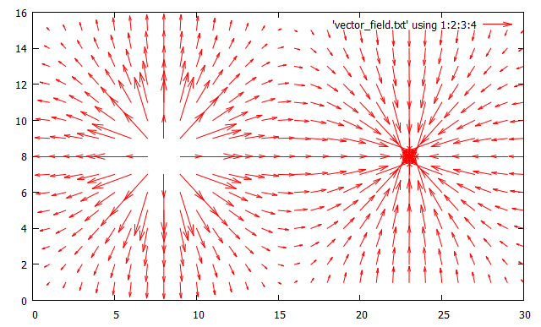

Figure 5: The electric field in the box.

My program takes 191 iterations to calcualte the field. The graph of potential and Electric field seem believable.